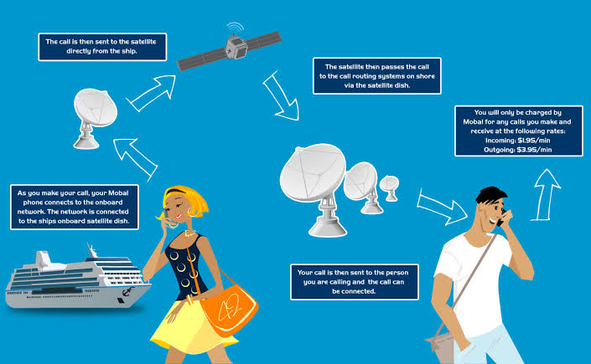

satellite phones

If you’re a fan of military- action movies or political dramas, you might’ve heard about something called “sat phone”. Here’s an article about Sat Phones, to help you understand how they work in real life

A satellite phone, popularly known as the sat phone, is a mobile phone which uses satellites, not landline or cellular broadcasting towers, to make or receive calls. It works through the help of three satellite networks

The three main satellite networks are the Iridium, Globstar and Thuraya. Iridium uses low orbiting satellites that minimises conversational delays, but more importantly, it is the only satellite network that provides coverage across the world, including the oceans.

Globstar covers around 80 per cent of the earth's landmasses, excluding the northern and southern polar regions.

Thuraya covers parts of India, Asia, Africa, the entire Middle East and Europe. Sat phones are specifically manufactured for a particular network and do not work on other networks

While making or receiving a call, the signal first travels to the orbiting satellite and then to an earth-bound gateway, before being routed to the receiver. The receiver's response will follow the same path in reverse, taking an equal amount of time to reach the caller.

The mobile equipment, which is also known as a terminal, varies in size. The instrument, which is fitted with retraceable antennae, is not as sleek as a mobile phone. A satellite phone resembles the models of mobile phones that were available in Indian markets ten years ago.

How does it cost?

The oldest models cost approximately Rs 10,000 while the latest model, the iconic Iridium 9505A, costs a whopping Rs 49,975.

Some companies offer sat phones on rent, and the weekly rent is approximately $24 (Rs 1,200 approximately).

The cost of making calls from a satellite phone varies between Rs 7 and Rs 99 per minute. However, calling a sat phone from a land phone or a mobile phone is extremely expensive and charges range from Rs 149 to Rs 699 per minute.

The sat phone also offers messaging service and the rates are approximately $0.59 (Rs 25) per message.